***Circulation Homework*** Name ___________________________

Homework #2

6th Grade PSI

1. Look at the map of prevailing winds below. Locate one country that receives prevailing winds that carry a lot of moisture. Put a red dot on this country. Locate one country that receives prevailing winds that are very dry. Put a green dot on this country.

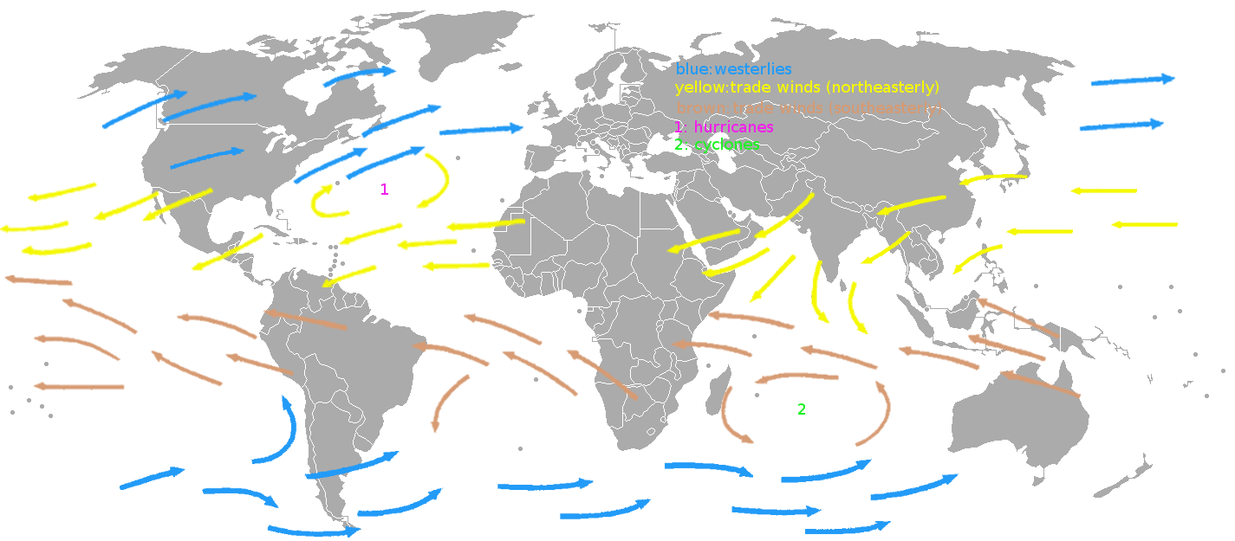

1. Some air masses are warm while others are cold. Describe how each type of air mass can carry different amounts of moisture with them.

________________________________________________________________________________________________________________________________________________________________________________________________

1. Oceans are an important aspect of regulating Earth’s climate and weather.
   1. Describe how oceans regulate climate.

_________________________________________________________________________________________________________________________________________________________________________________

* 1. Describe how oceans affect weather.

_________________________________________________________________________________________________________________________________________________________________________________